Lecture 26

Hiring Winners Part2 (Live Session 23 October 2022)

Go for interview as a winner even if u r fresher

Plan the interview 🡪 its not a single day preparation.

Watch interview prep lecture and note it down and learn it **by-heart.**

First 7 minutes for introduction,

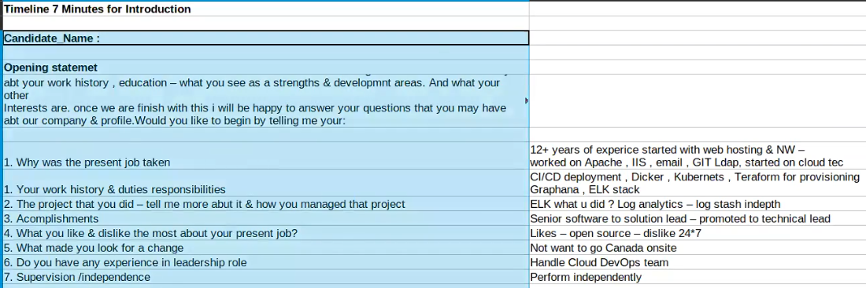

Next 20 minutes for technical part.

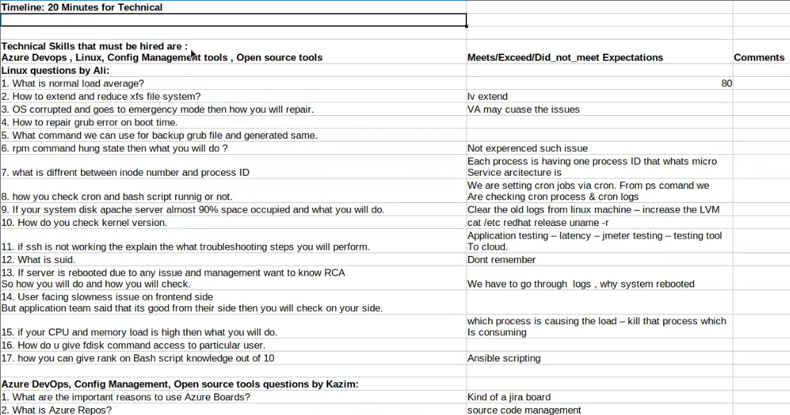

.

Creativity side question (10 minutes)

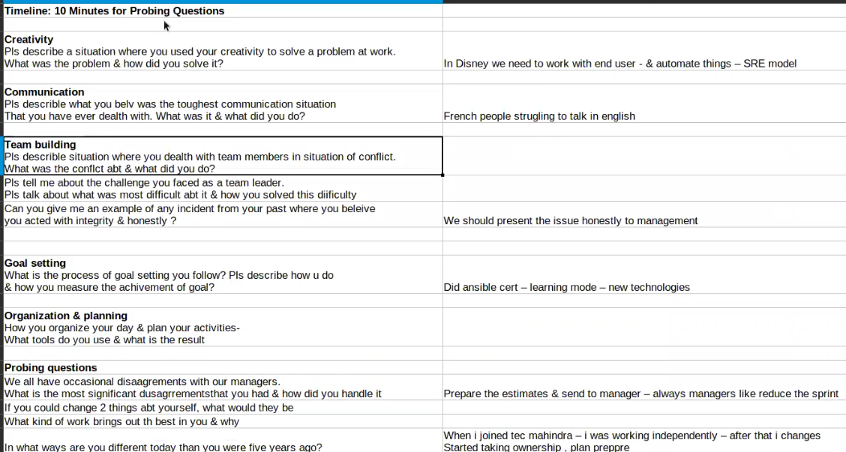

.

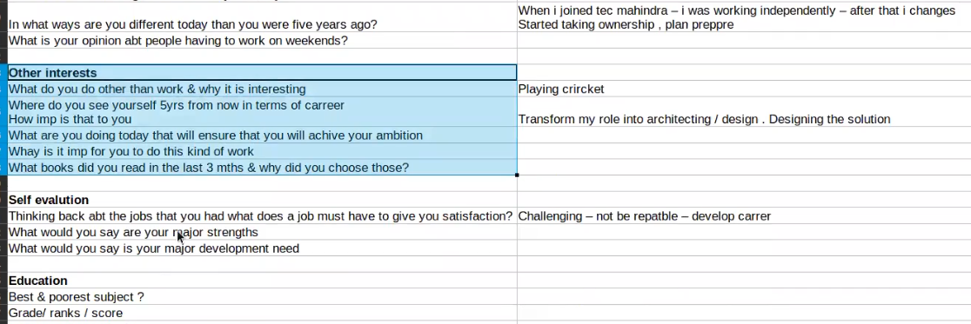

.

Closing note

.

.